Option one (easier): DnD photo map

Description
- Draw a map on paper/tablet/computer. Make a picture of it. Upload it in interactive map program (IMP).
- In the IMP, overlay the picture with a grid of squares. Grid size and square amount can be adjusted.
- Select squares that are obstructed, e.g. squares where trees are drawn (char can’t walk through trees).
- Characters and monsters can be placed on the map. Chars contain:
  - resizable image of the character: you see this on the map.
  - size
  - HP, MP, etc.
  - movement speed: x yards per round. Scale of map and gridsize converts this to gridsquares/round (6yd/round on a map with 2x2 squares = 3 squares/round, see pic below)
  - number of attacks / round
  - number of spells / round
  - Action points is always 100, each action reduces action points, for example:
    - Action points: 100
    - movement speed: 3 gridsquares/round (each square move deduces 33,33 Action points)
    - att/round: 3 (each attack deduces 33,33 Action Points)
    - spells a round: 2 (each spell deduces 50 action points)
  - attack range based on equipment (longsword, crossbow) or spell specifics
  - methoden voor hun abilities/skills die visueel kunnen zijn? (lightning, fire, etc)
  - equipment
- Parts of the map can be obscured when not yet dicovered. When char moves into visibility range tiles become visible.

- Character can move horizontal, vertical and diagonal, but always within movement limit, see pic below.
  - if char can move 6 yd/round
  - if squares are 2x2 yd. A horizontal or vertical move is 2 yd (char can move 3 horizontal/vertical squares). A diagonal move is 2,83 yd (a² + b² = c² , diagonal is about 141.5% of horizontal/vertical) (char can move 2 diagonal squares).
  - Clicking on a character/monster will highlight the grid squares to which it can move based on its movement speed and remaining action points.
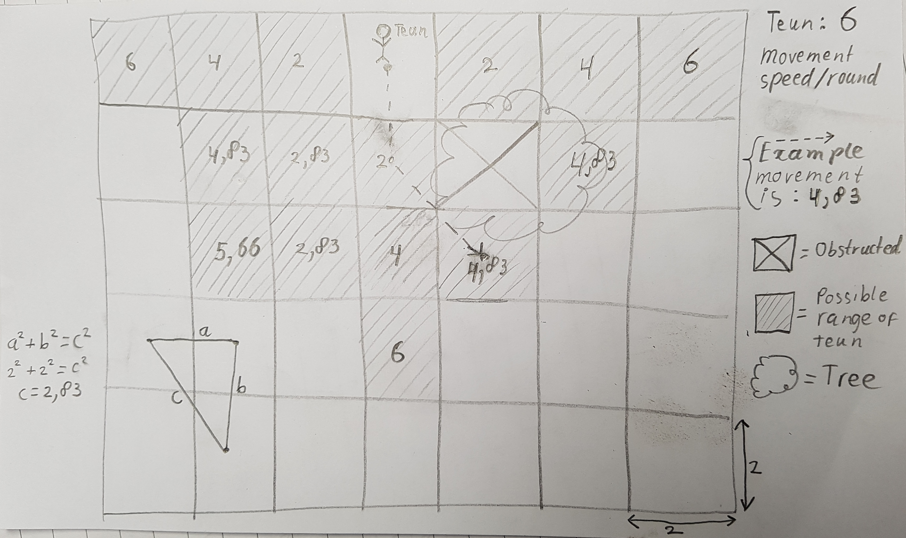
  - In example above Teun moves 4,83 yards and can’t make another move (not enough movement left to move an entire tile). With 100 Action points, each moved yard deduces (100/6=) 16,67 action points. Teun has used (16,67*4,83=) 80,52 action points, so he can still use 19 action points for attacks or spells.

Use cases editor mode
- Upload map picture
- Overlay map with grid:
  - choose scale and gridsize
- Make tile obstructed (e.g. a tree tile will be obstructed so chars and monsters can’t move over that tile (unless flying)).
- Place exisiting character/monster on map
- Create new monster (stats and abilities and whatnot)
- Create equipment item

Use cases play mode:
- Make grid overlay visible/invisible
- Move character or monster on map
  - movable objects have movement limits
  - number of actions are reduced by a characters performed movement
  - movable distance is reduced by a characters performed actions
- Do an action (each action reduces action points):
  - attack
  - cast spell
  - move (partial)
- See HP/MP stats of the party
- See character info (description, stats, exp, skills, equipment)
  - involves database
- See movement range of a character/monster

Option two (more difficult): Elaborate map editor (a real editor, not a picture of a drawing, much more eleborate)
Description
- Grid of squares on which terrain and objects can be placed:
  - Terrain like: grass, desert, cobbles, etc.
  - Objects like: trees, rocks, mountains, rivers, lakes, roads, chests, etc.
  - This involves a big database of objects, with many many objects which all have their own graphical representation (e.g. pics of trees, pics of mountains, etc.).
    - Maybe you already have a lot of pictures of these objects in your photoshop map system?
- Some objects are carriers (a mountain is a carrier because it can carry other objects, like trees), some are carry-able (a tree is carryable because you can place it on a mountain).
- Some objects are extendable: a river tile can be added to another river tile, extending the river. Roads too.
- DM is always free to switch between creation and play mode.

Use cases editor mode
- Create map
  - choose grid size
- Place object on map
- Move object on map
- Change object size
- Make playable?

Use cases play mode:
See option 1 use cases.

Troubles:
If we want to keep updated lists of equipment per character and stored in treasure chests, etc. we need a vast database of items. This is impossible to have at the start. Solution: DM can create items and place them in treasure chests for the party to find. Database of items will grow and grow the longer you play. Exisiting items can of course be re-used/copied for next roleplay sessions. New problem: need an item creator. Maybe keep equipment on paper and see if an item creator can be one of the feature requests in the future?

